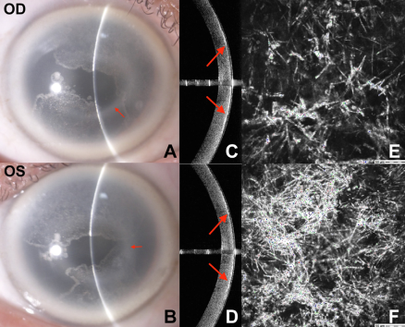

A 67-year-old White man was referred for corneal opacities observed during routine examination. He was asymptomatic with unremarkable medical and family history. Best-corrected photopic visual acuity was 20/20 bilaterally. Slit-lamp examination of both eyesshowed arcuate paracentral subepithelial crystals extending centripetally from the midperipheral cornea overlying an arc of dense paracentral haze with well-demarcated margins sparing the visual axis (A and B). Arcus lipoides was also noted. Anterior segment-OCTdemonstrated focal subepithelial hyperreflectivity on both sides of the line scans (C and D). Subepithelial crystalline deposits were observedby in vivo confocal microscopy (E and F). Polymerase chain reaction identified heterozygous N102S mutation in the UBIAD1 gene.Based on the provided images and clinical description please make an ophthalmic diagnosis for this patient. And output the diagnostic conclusions only.

**Schnyder Crystalline Corneal Dystrophy**